Kanan Ibadzade

Efe Gur Bahadir, Jarred Chen, Zhi Hao Chong

Conservation of Momentum and Motion of the Center of Mass

OBJECTIVE

1) Confirm the Law of Conservation of Momentum.

2) Determine if a collision is elastic or inelastic.

3) Confirm that the velocity of the center of the mass is constant for an isolated system.

THEORY

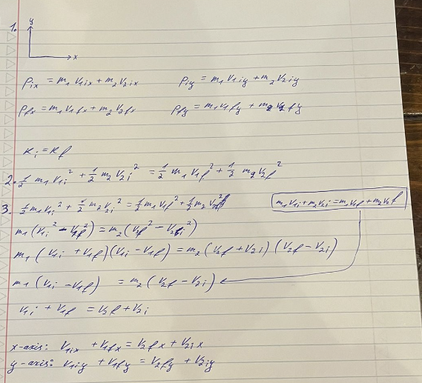

EQUIPMENT

1. Air puck table

-simulate a frictionless surface to conserve the momentum

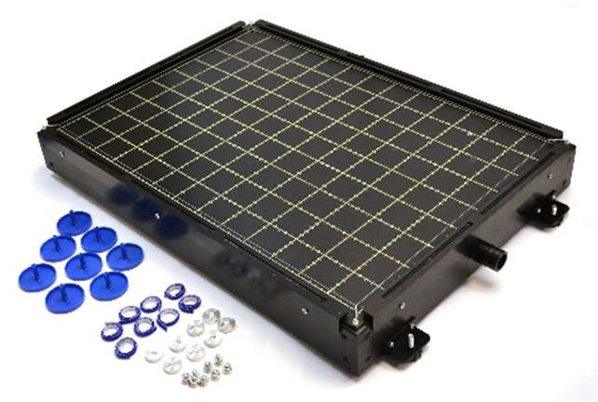

1. Two pucks

-act as the colliding objects



1. Spark generator

-generate markings along the path of pucks’ movement



1. Recording paper

- track the movement of the pucks



5. Triple-Beam Balance

-weigh the mass of pucks



PROCEDURE

1. Using the air puck table and two pucks, collect data (with the assistance of your instructor) that resembles the two collisions shown above.
2. By using as many spark holes and the corresponding frequency of the spark generator, calculate the speed of the pucks before and after the collisions.
3. Measure the mass of the pucks and the appropriate angles.
4. Using the equation obtained in the theory section calculate the momentum, kinetic energy, and Vcm before and after the collisions.

DATA

|  |  |  |  |  |  |  |  |
| --- | --- | --- | --- | --- | --- | --- | --- |
| Mass (g) | vi (m/s) | vf (m/s) | Distance before  collision (cm) | Distance after  collision (cm) | Time before collision (s) | Time after collision (s) | Angle after  collision (°) |
| 522.30 ±  0.01 | 0.600 | 0.206 | 16.00 ±  0.05 | 22.00 ±  0.05 | 4/15 | 16/15 | 44.0 ± 0.5 |
| 526.52 ±  0.01 | 0 | 0.400 | 0 ± 0.05 | 16.00 ±  0.05 | 0 | 6/15 | 30.0 ± 0.5 |

CALCULATIONS

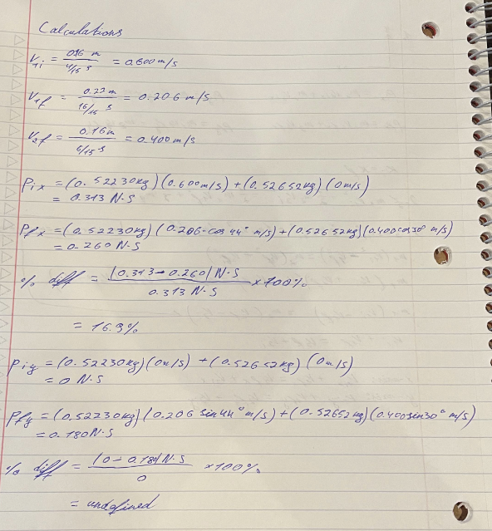

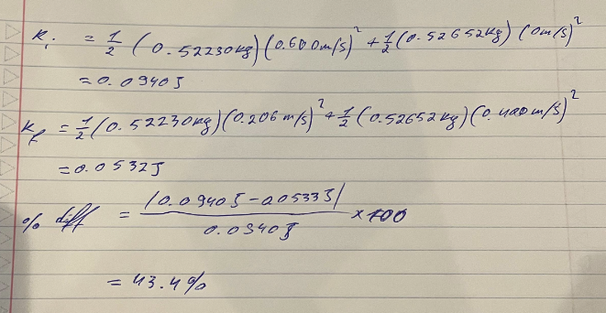

CONCLUSION & RESULTS

Based on the calculation from the theory section, the momentum analysis shows a 16.9% difference in the x-axis momentum and a non-equivalency in the y-axis momentum prior to and following the impact. This suggests a loss of velocity, indicating an inelastic collision. At 43.4%, the kinetic energy loss is converted to heat and sound. A constant center of mass velocity (Vcm) appears to have occurred during the experiment based on the almost similar total velocities before and after. The lab's objectives were to characterize the type of collision, test the conservation of momentum law, and confirm that the center of mass velocity in an isolated system remains constant. These objectives were accomplished with the help of my lab companions and professor. The findings validate an inelastic collision by demonstrating a departure from momentum conservation. The center of mass velocity equation shows the consistency of the theory in an isolated system. A key systematic error identified was the miscalibration of the triple-beam balance, which impacts momentum calculation due to its direct proportionality to mass. This miscalibration likely inflated the observed percentage difference in total momentum pre- and post-collision. Friction between the pucks and the recording paper surface resulted in a random mistake. The masses' post-collision orientations may have been altered by this friction, which would have affected the momentum computation on both axes. As a result, there may have been a greater difference in overall momentum before and after the impact.